|  |  |  |  |  |  |
| --- | --- | --- | --- | --- | --- |
| Date | 9-Dec-22 | | | Tester Name | Andrew McLaughlin |
| Environment | Penfax - Test | | | Login used |  |
| Operating System | Windows | Version: | Update: | | |
| Software Used | Edge | Version: | Update: | | |
| Select Software | Version: | Update: | | |
| Release version | 22.4.1 | | | | |
| Title | M44.04 Payment amounts agree ATB | | | | |
| Test Type | Regression | | | | |
| Test Scenario | M44.04 Payment amounts agree ATB | | | | |
|  |  | | | | |
| Expected Results |  | | | | |
| Pass/Fail | Pass | | | JIRA# | N/A |

Describe your steps with screenshots:

After performing the Pre-Payroll Runs (44.01), add a Monthly Production payroll batch for all plans except PEPP/WCB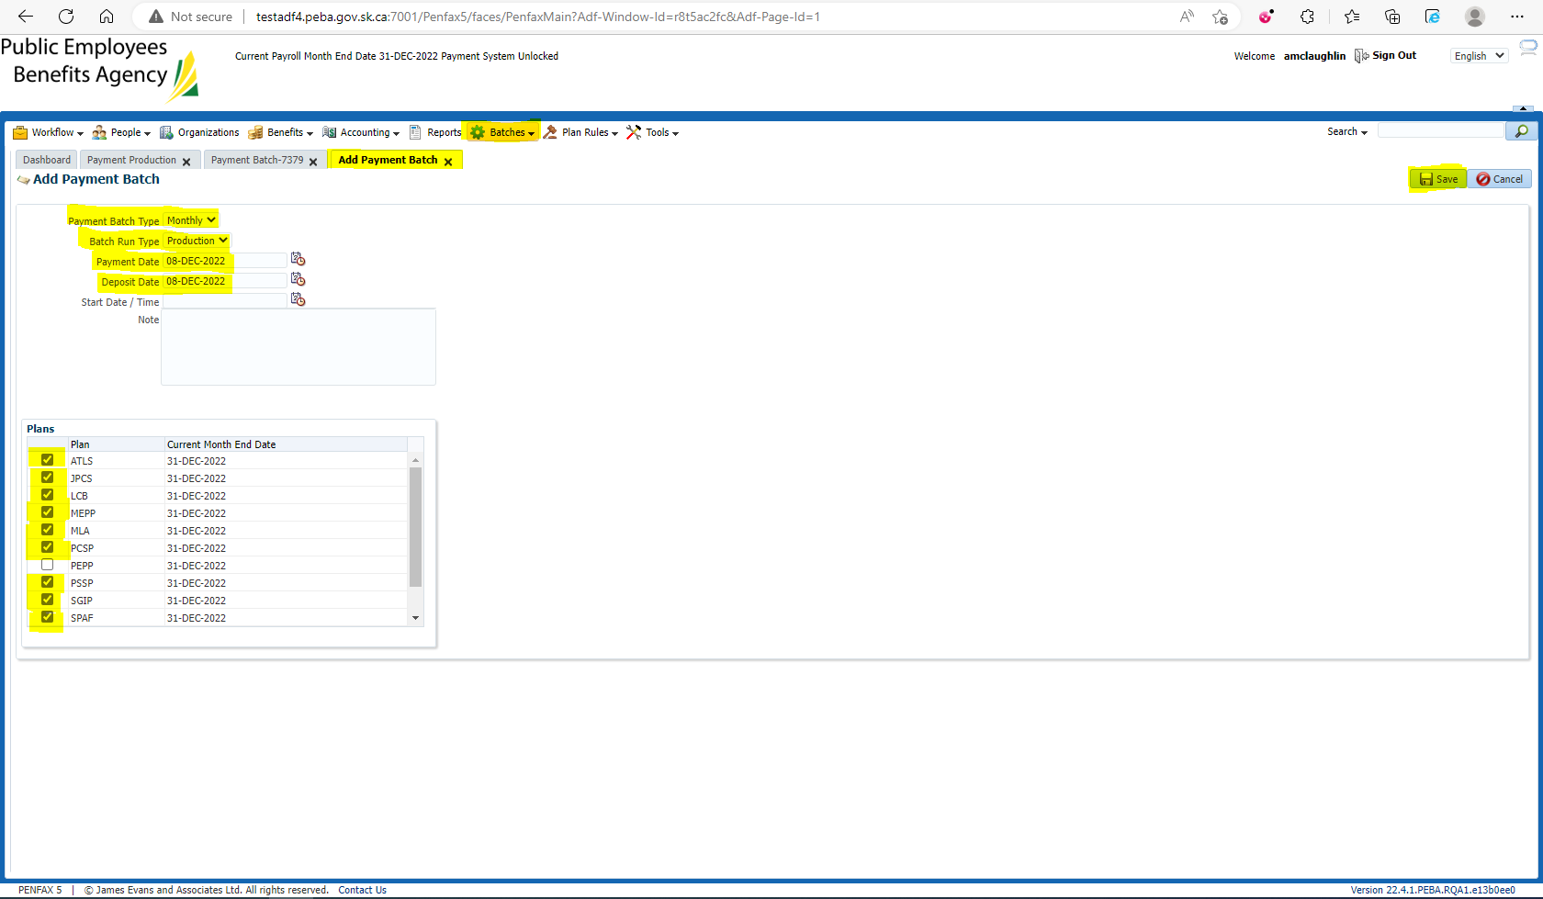

Once the payroll batch has been Completed successfully, Process the batch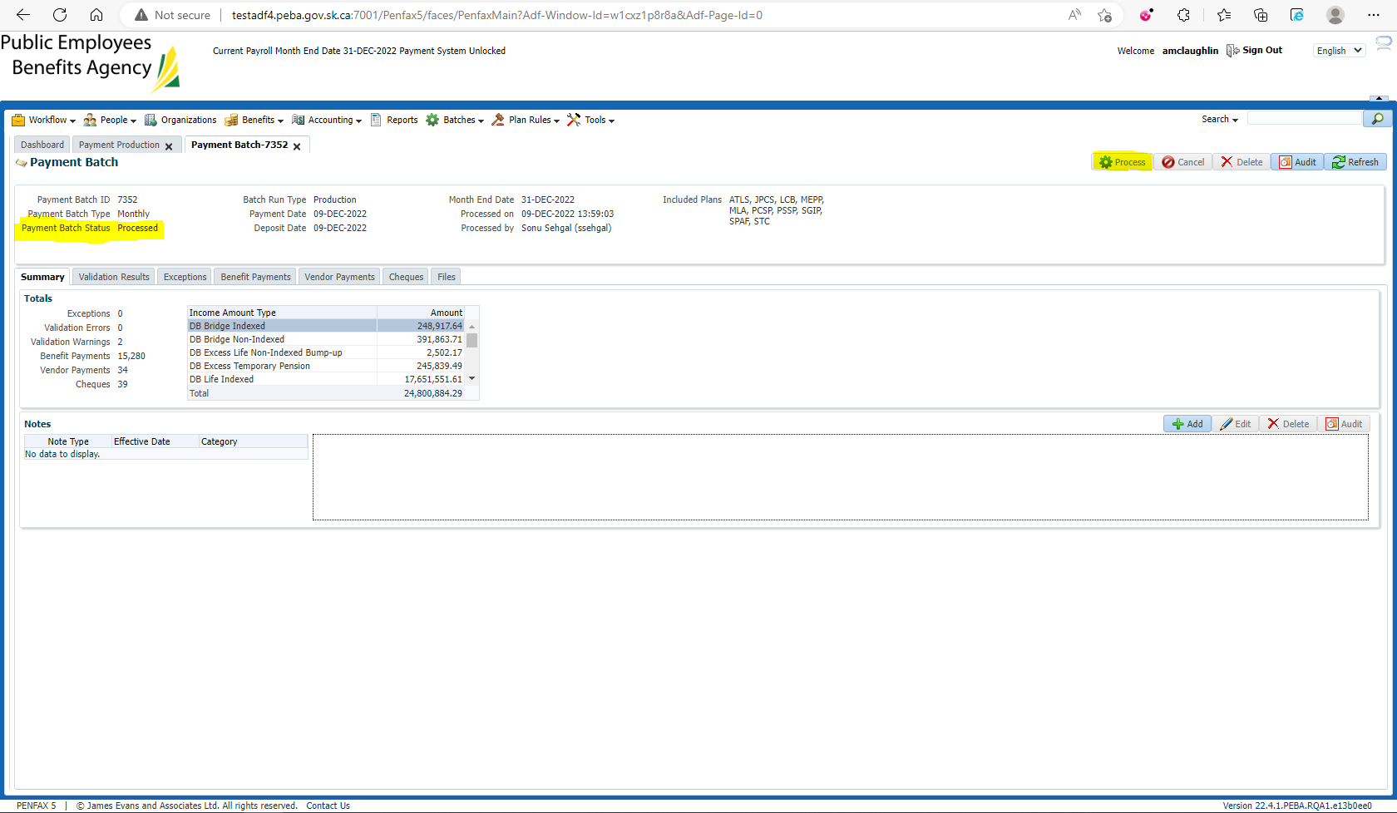

Once the batch has been processed, check the Payment Batch tab to ensure that the reports have been produced for each plan in the batch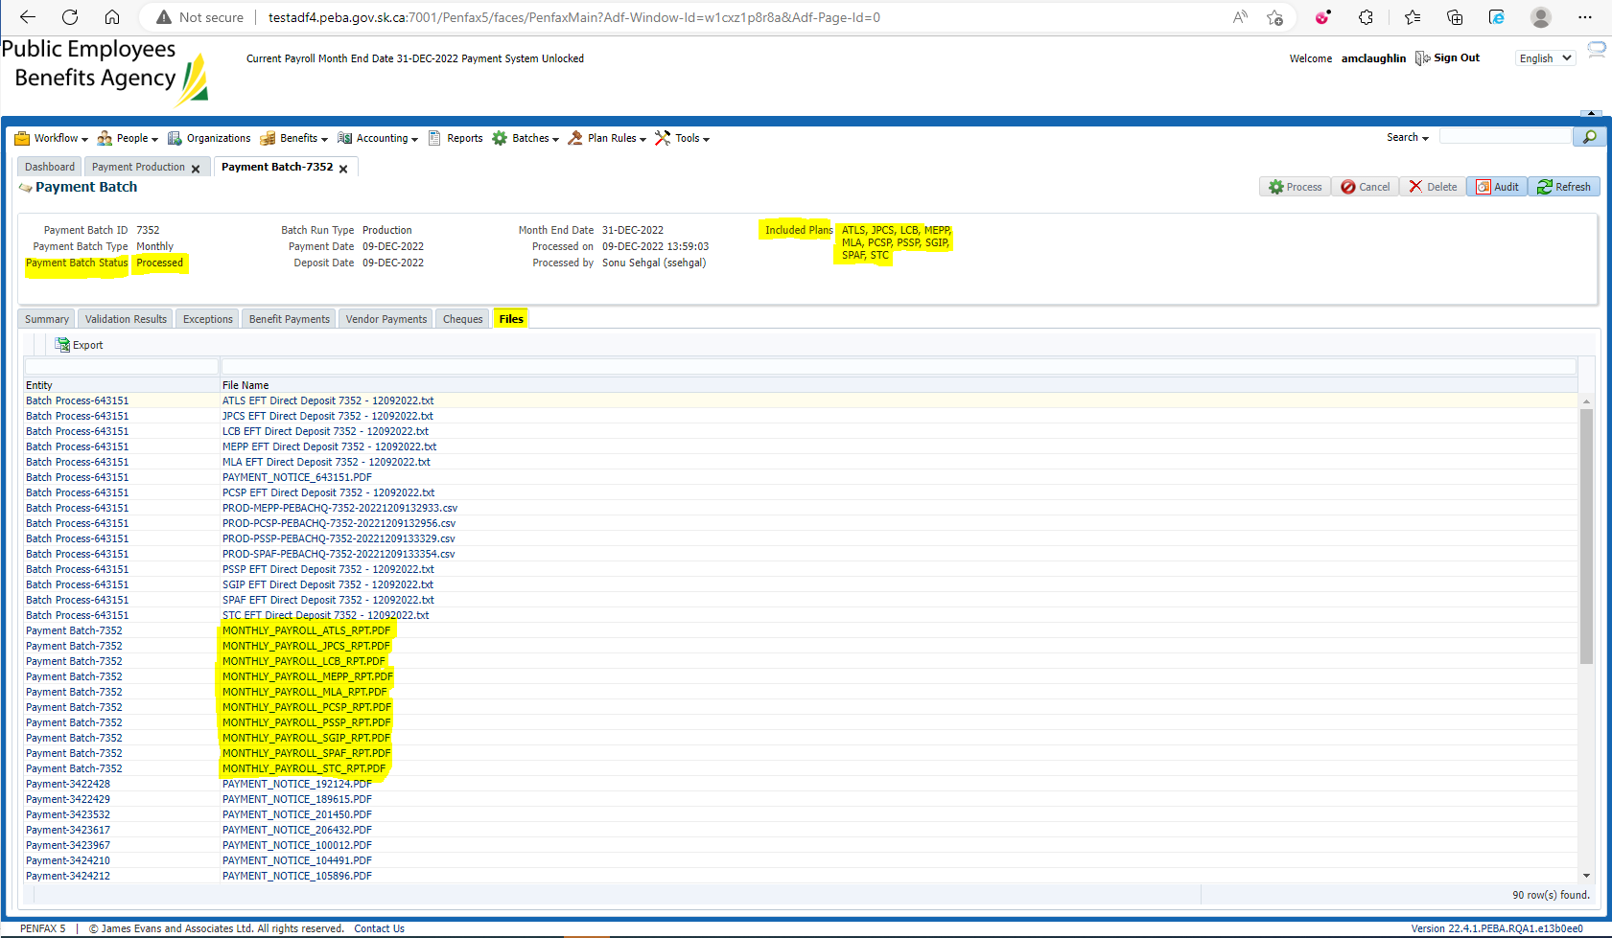

Verify the contents of the reports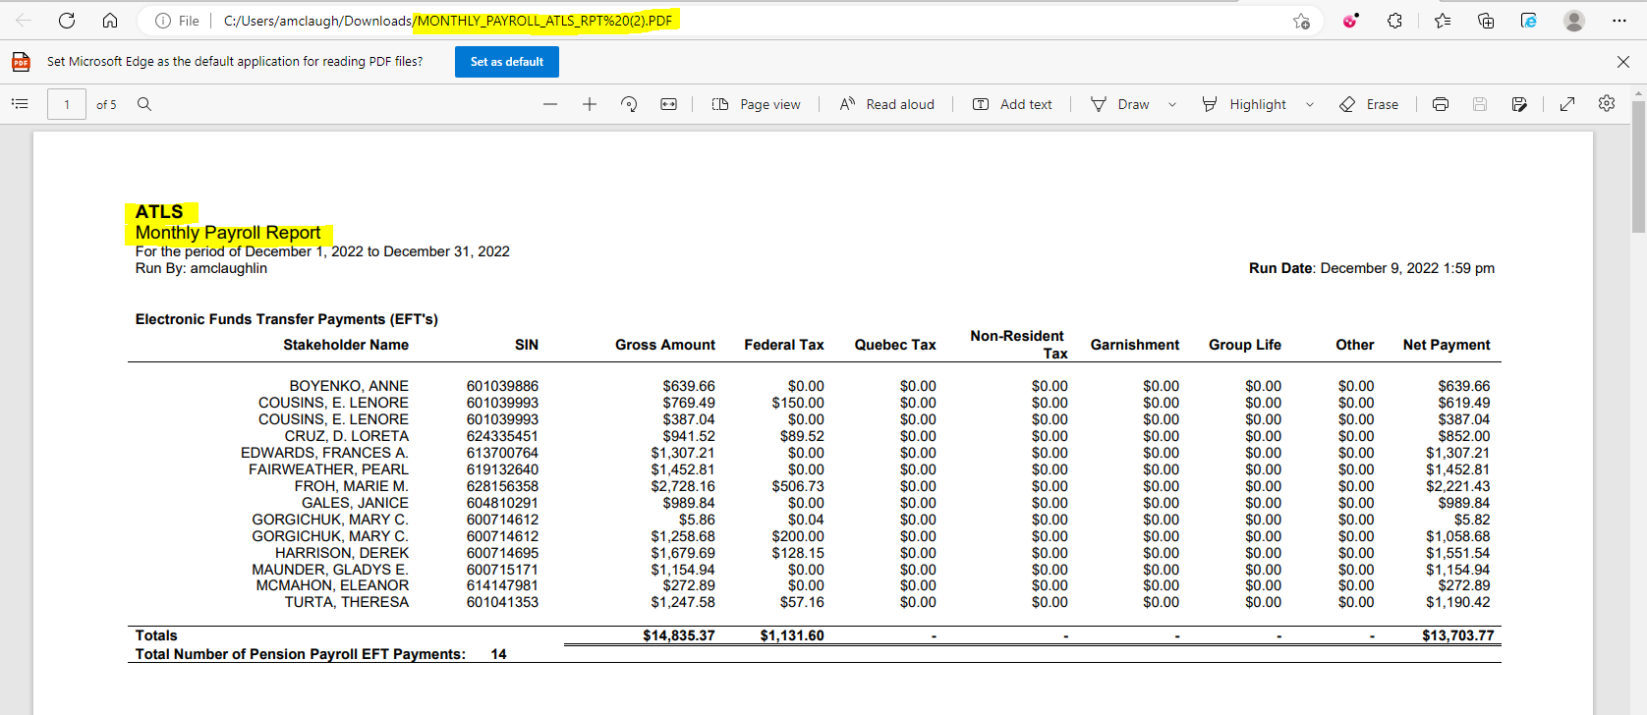

Ensure in the member’s Payment History that the payment matches the Payroll Report Ensure that the Payment History matches for the payments received in the report 